**Leading University**

**Department of Computer Science and Engineering CSE 4800**



**Gen Z Cracks: Pursue your knack**

Fariha Chowdhury

Anisur Rahman

Jannatul Ferdous Sabrin

ID 2012020053

ID 2012020229

ID 2012020251

Department of Computer Science and Engineering

**Submitted To**

Rumel M. S. Rahman Pir

Associate Professor & Head

Department of Computer Science and Engineering

06 April, 2023

# Abstract

Our Project Hash-IT is based on Developer Freelance Platform. Freelance marketing jobs have become increasingly popular as a desirable and worthwhile career choice as the business world has evolved and changed over the past few years. This Website will be only for Developers which makes it easy for developers to find and connect with each other and work on projects together through collaboration. So you are not only getting fast and easy real world experience but you are also connecting with developers who are around your skill level. This would be a  way to level up and an easy way for beginners to get work alongside you don't need to stress over interviews. And there could be some form of onboarding and maybe tests depending on the work and the developers who work on it. There will be at least 4 types of panel to be used. These are, 1.Users/Freelancer 2.Admin 3.Management/Employer 4.Payment Processor. Users have to create a profile, display their work portfolio, and chat with employers. Hash-IT allows digital-age workers to experiment with almost anything they want without having to first win over the approval of the traditional authorities. The website wants to provide an opportunity for them to make money from a passion project or to try something they've always desired to. However, some professions and jobs adapt themselves particularly well to the advantages of working. They consist of: Web Development, Graphics Design, Photography, Videography, Content writing, Digital Marketing and there will be many more. Lastly, as our Project is Web-based, HTML5 CSS JS Bootstrap and more technologies are used to develop the Website.

# 

# Acknowledgements

First of all, we would like to express our deepest gratitude to Almighty Allah for his blessings on us. Next, we would like to thank the Department of Computer Science and Engineering, Leading University, Sylhet, Bangladesh for supporting this course work. Our special thanks go to our supervisor who gave us this opportunity to work with him and initiated us for the project called “Hash-IT”. His encouragement, visionaries and thoughtful comments and suggestions helped us a lot. We would also like to thank all the teachers of the Department of CSE in Leading University for providing the facilities and opportunities to prepare this work. Last but not the least, I would like to thank my parents and friends for their unending support, encouragement and prayers.

.

# Dedication

We would like to dedicate our work to our parents, relatives and friend

# Contents

Abstract . . . . . . . . . . . . . . . . . . . . . . . . . . . . . . . . . . . . . . . . . . I

Acknowledgement II

Dedication III

Table of Contents IV

List of Figures V

1. Introduction 1
   1. Background . . . . . . . . . . . . . . . . . . . . . . . . . . . . . . . . . . . . . 1
   2. Motivation . . . . . . . . . . . . . . . . . . . . . . . . . . . . . . . . . . . . . . 2
2. Background Study 3
   1. Review Previous Work . . . . . . . . . . . . . . . . . . . . . . . . . . . . . . . 3
3. Methodology 5
4. Structural Design 6
   1. Use Case Diagram . . . . . . . . . . . . . . . . . . . . . . . . . . . . . . . . . 6
   2. Data Flow Diagram . . . . . . . . . . . . . . . . . . . . . . . . . . . . . . . . . 7
5. Limitations and Future Work 9
   1. Limitations . . . . . . . . . . . . . . . . . . . . . . . . . . . . . . . . . . . . . 9
   2. Future Work 10
6. Conclusion 10

**7 Reference 11**

# List of Figures

* 1. Use Case Diagram . . . . . . . . . . . . . . . . . . . . . . . . . . . . . . . . . 6
  2. Data Flow Diagram . . . . . . . . . . . . . . . . . . . . . . . . . . . . . . . . . 7

**Chapter 1**

# Introduction

## Background

Our project-II, Hash-IT, is a platform that makes it simple for freelancers to connect with one another, discover common interests, and collaborate on projects. Thus, they not only gain quick and simple real-world exposure but also interact with other developers who have similar skill sets. This is a great method to advance and a simple way for newcomers to find employment. Many businesses are opting for these websites for getting their job done by the remote workers. There will be a log-in system for User. Users will have to fill-up a detailed form to create an account. On the other hand, there will also be a management panel where they can hire freelancers, manage job posts, make payment. Lastly, there will be an admin panel where admin will have full access of the websites, can block profiles, make necessary changes and see everything. Also there will be a Payment processor that will process transaction of the payment.

## Motivation

We are living in a world where hundreds and thousands of millions people are unemployed even after graduated. But, professionals have access to remote jobs from almost every corner of the world. However, we have a huge number of professionals graduating with highly in-demand skills but struggling to get jobs and gain experience .This is because most companies need experience. We also have multiple companies that need such professionals but are afraid of making long-term commitments with individuals without sufficient experience due to legal risk and the high cost of managing human capital. Individuals without experience require training, which these companies do not want to provide because of the time and financial burden. To overcome this problem, we are working on such project that will connect talented individuals with economic opportunities and help companies cut down on the cost of managing human capital by getting individuals to work for them on a short-term basis. Our website can help any educated, skilled jobless people from anywhere, anytime. We strongly believe that this website have the potential to help countless of people, if given enough care and effort. The goal of our project is to help as much people as possible

**Chapter 2**

# Background Study

There are many websites related to our project. As a result, our project is almost impossible to be completely unique. But, what we can do is, review those already existed websites and build our projects based on those websites limitation. Below listed some of these existed sites found and after researching these websites, we have found limitation which can be added into our project to be unique. The limitations are based on our own review of these apps and the user reviews found on Google itself.

## Review Previous Work

1. LinkedIn: It is one of the most popular job sites providing an easy way to find jobs in various fields. It’s also a social networking platform for professionals to connect and interact with each other. Browsing through LinkedIn job postings is also a great way to find freelance opportunities.

Limitations:

* There are many spam content from malicious users.
* LinkedIn does not provide as many ways of interacting with other users.

1. Fiverr: A website that allows users to find and hire professionals to do a wide variety of tasks. From designing a logo to creating a website, Fiverr offers a wide range of services and opportunities. Users can search through Fiverr’s extensive list of services or browse by category.

Limitations:

* High commission charge, long payment process.
* No guarantee that the person you hire will actually do the work. There have also been cases of people being scammed on Fiverr.

3. Upwork: A freelancing website to find jobs specifically catered to your specific skillset. It connects clients and freelancers from across the globe. The platform provides a wide range of categories, from web design and software development to customer service and accounting.

Limitations:

* Must have to pay Upwork’s commission fee.
* Upwork is not always reliable.

4. Toptal: A marketplace for top web developers, engineers, programmers, coders, architects, and consultants. Top companies and start-ups choose Toptal web freelancers for their mission critical software projects.

Limitations:

* Possibility of lower pay and employment insecurity for employees.
* High quality comes with a high price tag.

**Chapter 3**

# Methodology

For our project, we will follow some methods to set our goals and move forward with these methods in mind. These method will help set up a development path. These methods are:

1. **Analysis & Planning:** After reviewing multiple websites similar to our project, we analyzed and reported that there are lots of limitations which we can add into our project. As a result, this project can help lots of users.
2. **User interface**: Creating a simple but elegant UI is integral part of our project. Our goal is to keep the UI as simple as possible for the users to navigate through the website.
3. **Technological Background**: To implement the project, we used HTML (Hyper Text Markup Language), CSS (Cascading Style Sheets), JavaScript and MERN stack.
4. **Testing**: After our project work will be halfway through, we will spent brief time on Beta Testing for fundamental checkup of the website for bugs, optimization issue and many more. After our project work will be completely done, we will spent the rest of our time Alpha Testing for making the website as optimized as possible without any bugs. We will also have to keep in mind that our project is compatible with as many users as possible.

**Chapter 4**

# Structural Design

The Use Case diagram will used in identifying, clarifying and organizing the system requirement on how the system will be performing the tasks by making a set of possible sequences of the interactions between systems and users. And the Data Flow Diagrams will be used to demonstrate how information is transferred within the different processes of the system.

## Use Case Diagram

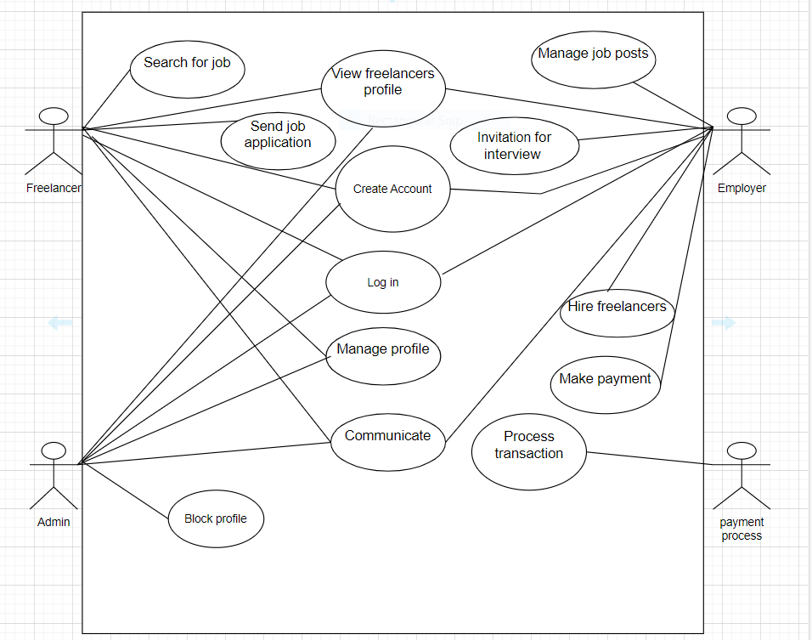

## Data Flow Diagram

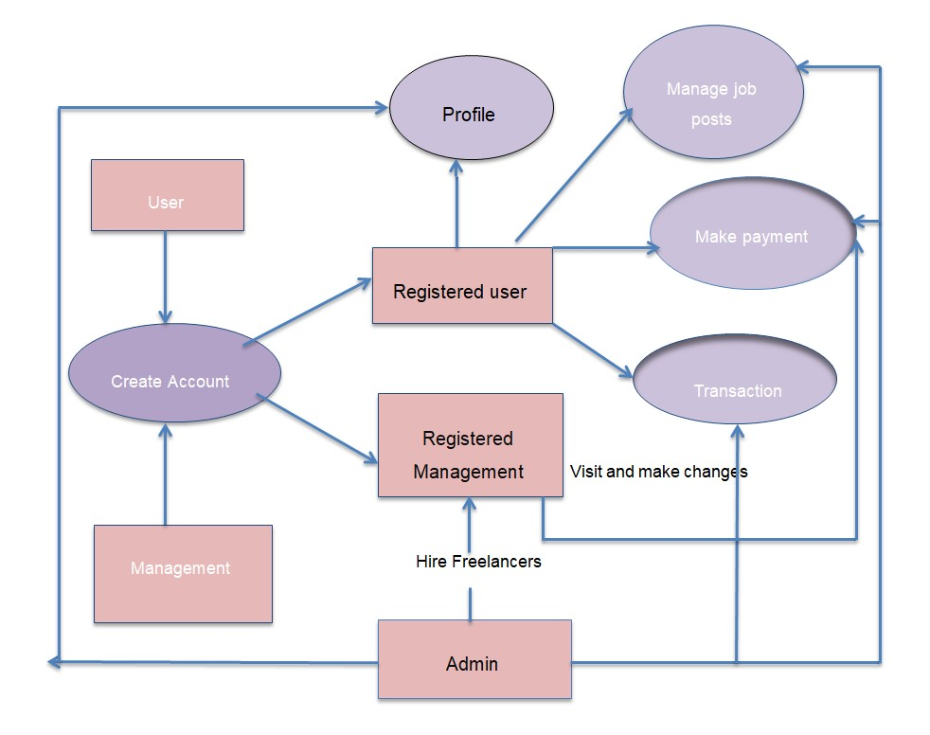

**Chapter 5**

# Limitations and Future Work

## Limitations

A Website is almost impossible to be flawless. Just like every other Website in the world, ours will have some limitation based on our project analysis and planning. Reasons for these limitations are limited resources, time constraint, need for higher level research, finding problems etc. Below will be stated the list of limitations:

* Doesn’t have the options to directly contact with the Freelancers through video call.
* It will be difficult for freelancers to gain early consideration for a position that has not yet been advertised through personal referrals.
* Workers are not the part of a company’s upcoming expansion plans.
* Fewer long-term contracts/work.
* Workers not having fixed salary.
* Bugs with Payment procession.

Note that these limitations are expected to change during our project time. We may fix some of the limitations or few more limitations might be added depending on the situation.

**5.2 Future Work**

Even though this project is for our academic study, we are doing this project for increasing our knowledge about Website development, freelancing works related study, taking our project to business level, reaching out to hundreds and thousands of people. We don’t have any intention to finish our project hastily and go through a short-way for obtaining higher grade. We would like to work on our project even after our project defense to make the website better, improving every aspect of the project and adding more features along the way. Some of the future works we will work on are listed below:

* Adding Chat Box / Frequently asked Questions.
* Adding Rating Options for betterment.
* Add more modules to strengthen the project.
* Adding video Chat Option.
* Add facial recognition system.
* Improving UI/UX continuously.
* Adding onboarding Questionnaire and English proficiency test.
* Increasing security.
* Adding various more platform in the future

Note that these future works are expected to change during our project time. We may work on some of these future works depending on the situation or also add few more future works might be added depending if we can get more ideas

**Chapter 6**

# Conclusion

This large-scale project is a first for us. We are embarking on a journey learning new programming language & spending as much time as possible for this project. This project is also very personal to us because deep inside, we all want to help people in our own way. This project has the potential help countless number of people if done right. This project is not only for our academic achievement but also for learning new technology development, honing our skill, dreaming and pursuing bigger things for this project. Even though our website might not be perfect, it will have few limitations as possible, but we will continue to work on it for as long as possible for maximum optimization, reaching this website to countless of people, for better user experience and many more.

**6.1 General Conclusion**

Modern company now heavily relies on the internet. By making it easy for developers to find and connect with one another and collaborate on projects, our initiative was created to help address young unemployment in Bangladesh. Employers and freelancers can now sign up for a platform with a few mouse clicks and browser interactions, that actually works to connect bright people with economic opportunities and give organizations access to affordable, low-risk human capital. Depending on how far they advance in the freelance belonging, people can now use their talents to earn a living.

# References

1. <https://rockcontent.com/blog/benefits-of-freelancing/#:~:text=15.-,Financial%20Security,choose%20to%20charge%20your%20clients>, Jan. 2019, pp. 1–4.
2. <https://faculty.washington.edu/hemay/reputations.pdf> , End-to-end speech synthesis,” 2021.
3. <https://icobest.unikom.ac.id/submission/proceeding/download/58>, 2007.
4. https://www.cscjournals.org/manuscript/Journals/IJBRM/Volume4/Issue1/IJBRM-141.pdf, 2014.

# Thank You